ECEN 454 - Lab Report

Lab Number: 8
Lab Title: Design of 8-bit Pipelined Adder
Section Number: 341
Student’s Name: Abhishek Bhattacharyya
Student’s UIN: 731002289
Date: 11/10/2024

TA: Nishank Bansal

Schematic w/ H Tree Pictured:

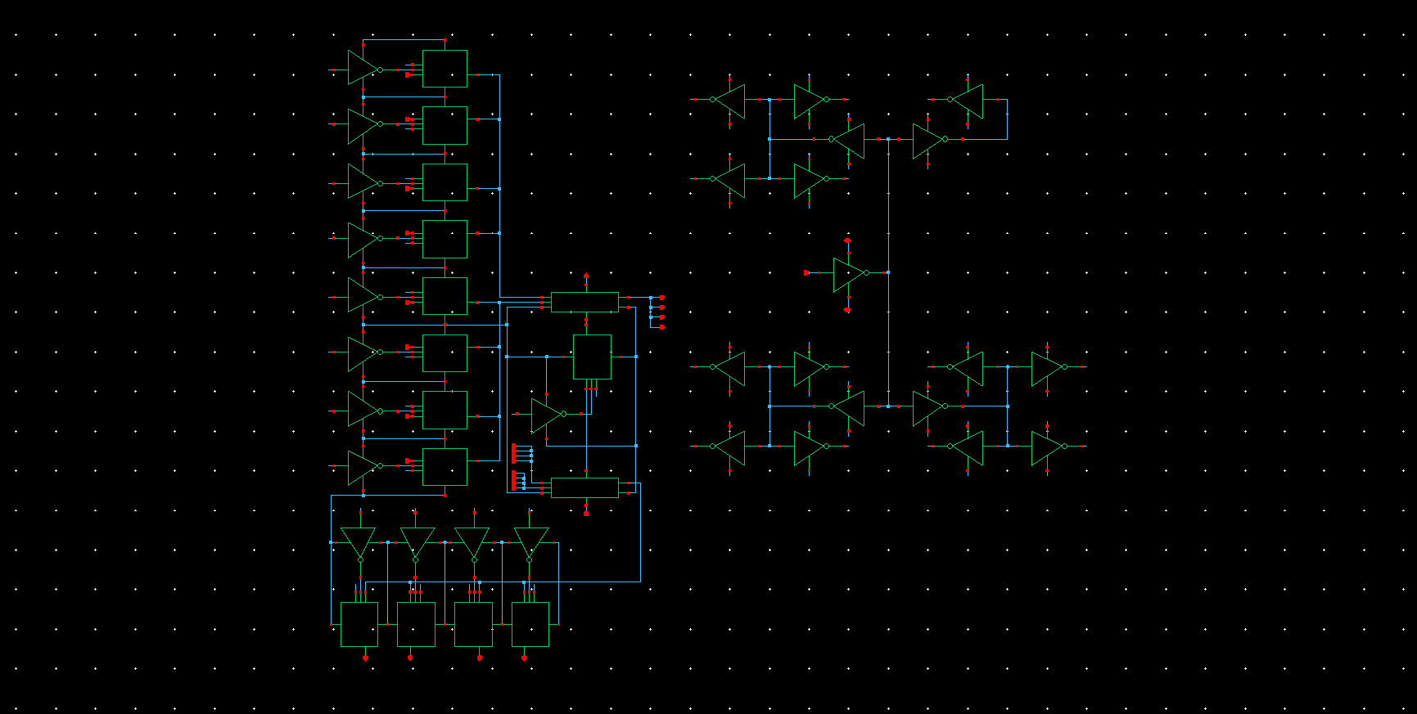

Layout

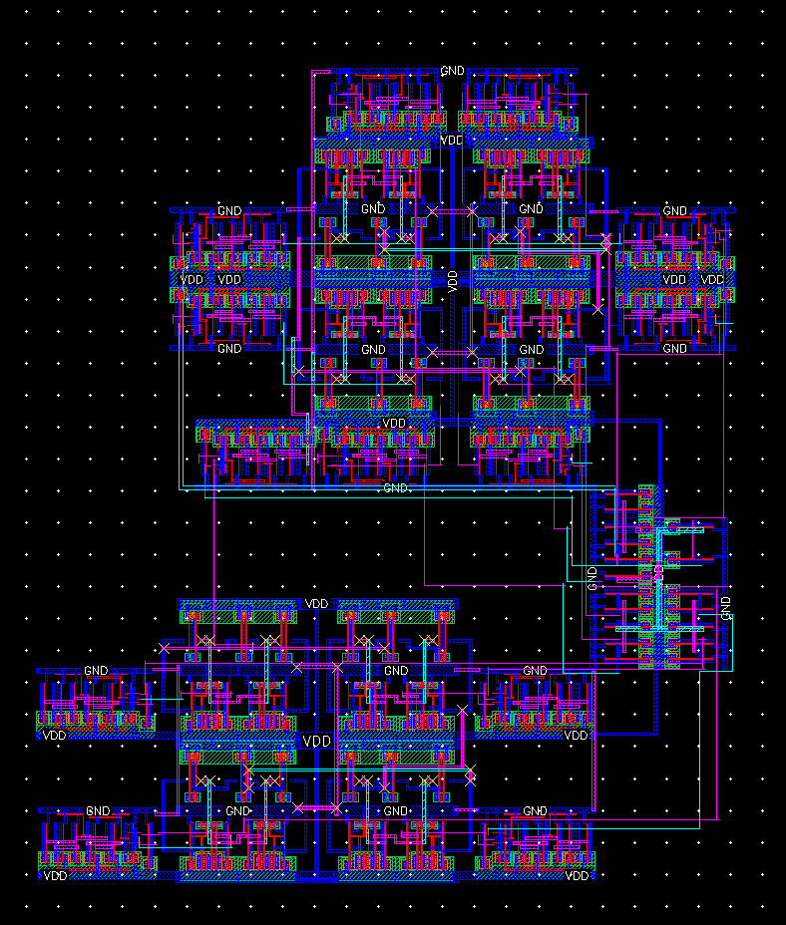

H Tree Illustration:
I configured the H tree in the layout as a block of inverters with the appropriate connections, to minimize the design area. This is still an H-Tree with equal length wires. This may be difficult to see in the layout, so I have provided a zoomed-in view and illustration below. I used trace net to highlight the first H (“net5”), and then the 4 low-level H’s (net9, 12, 15, 19). I used 0.8 width write for net5 and 0.4 width wire for the rest, following the instructions for wire width.
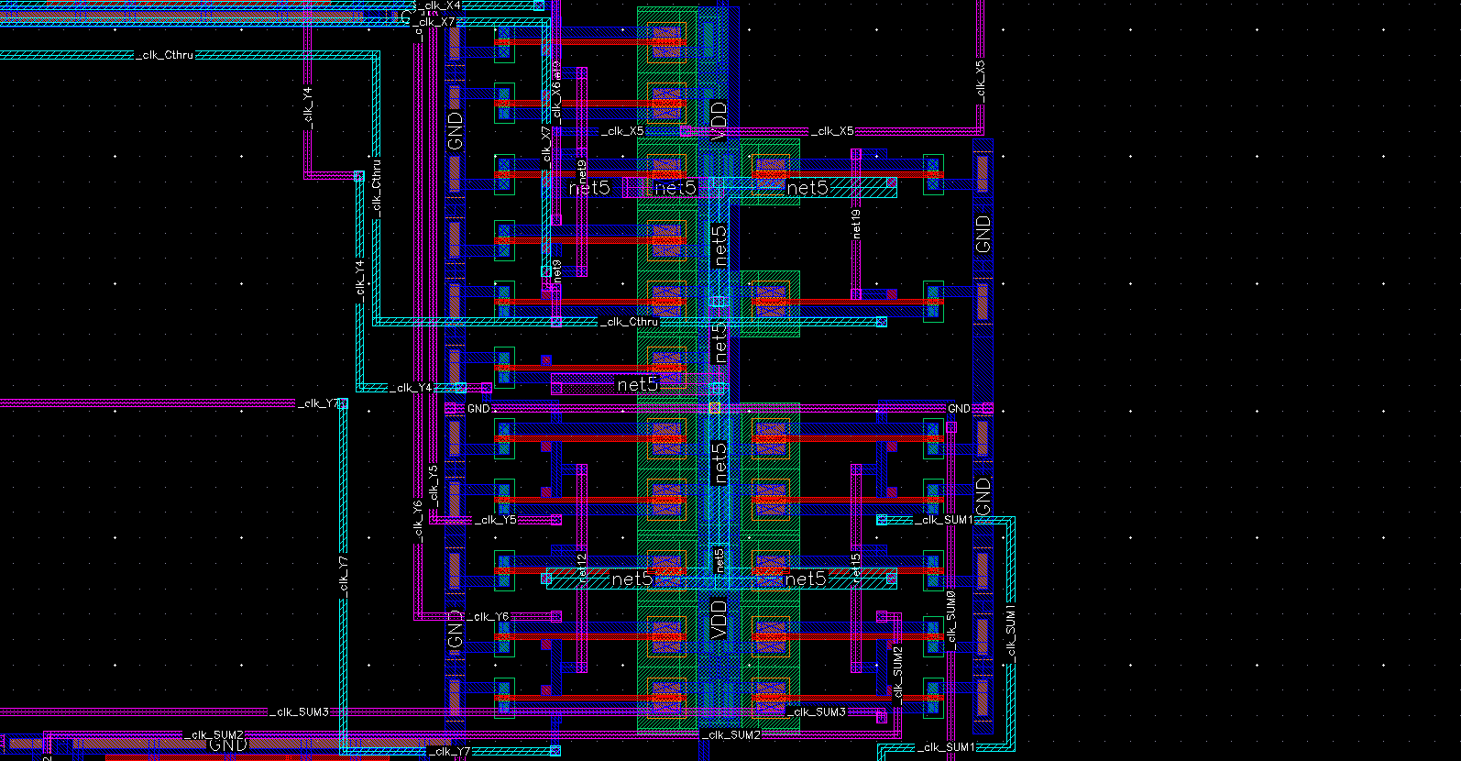
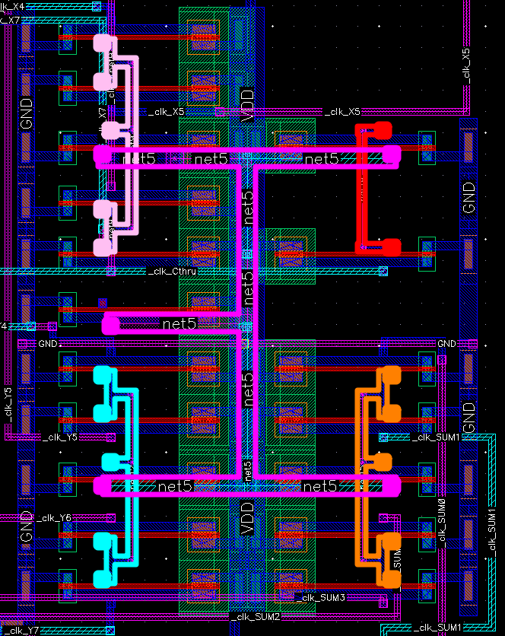

DRC/LVS Pass Report

DRC:

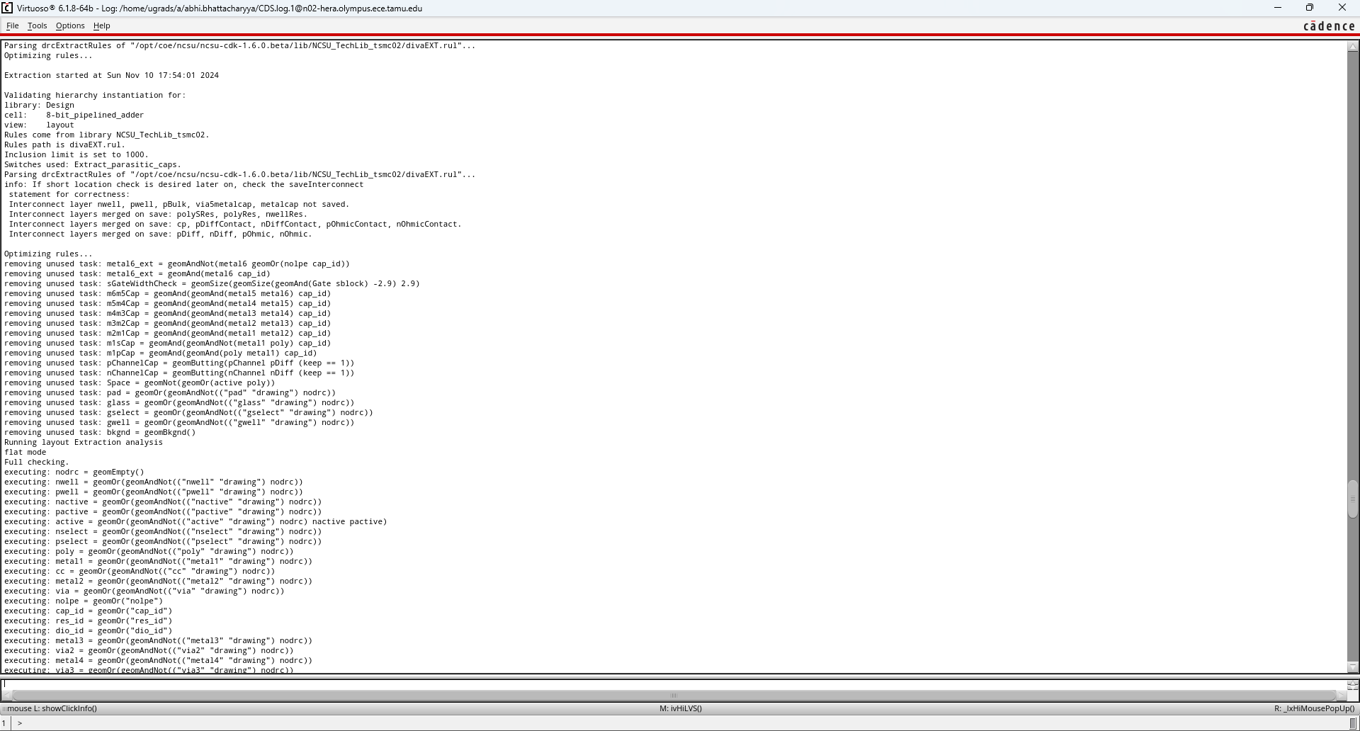
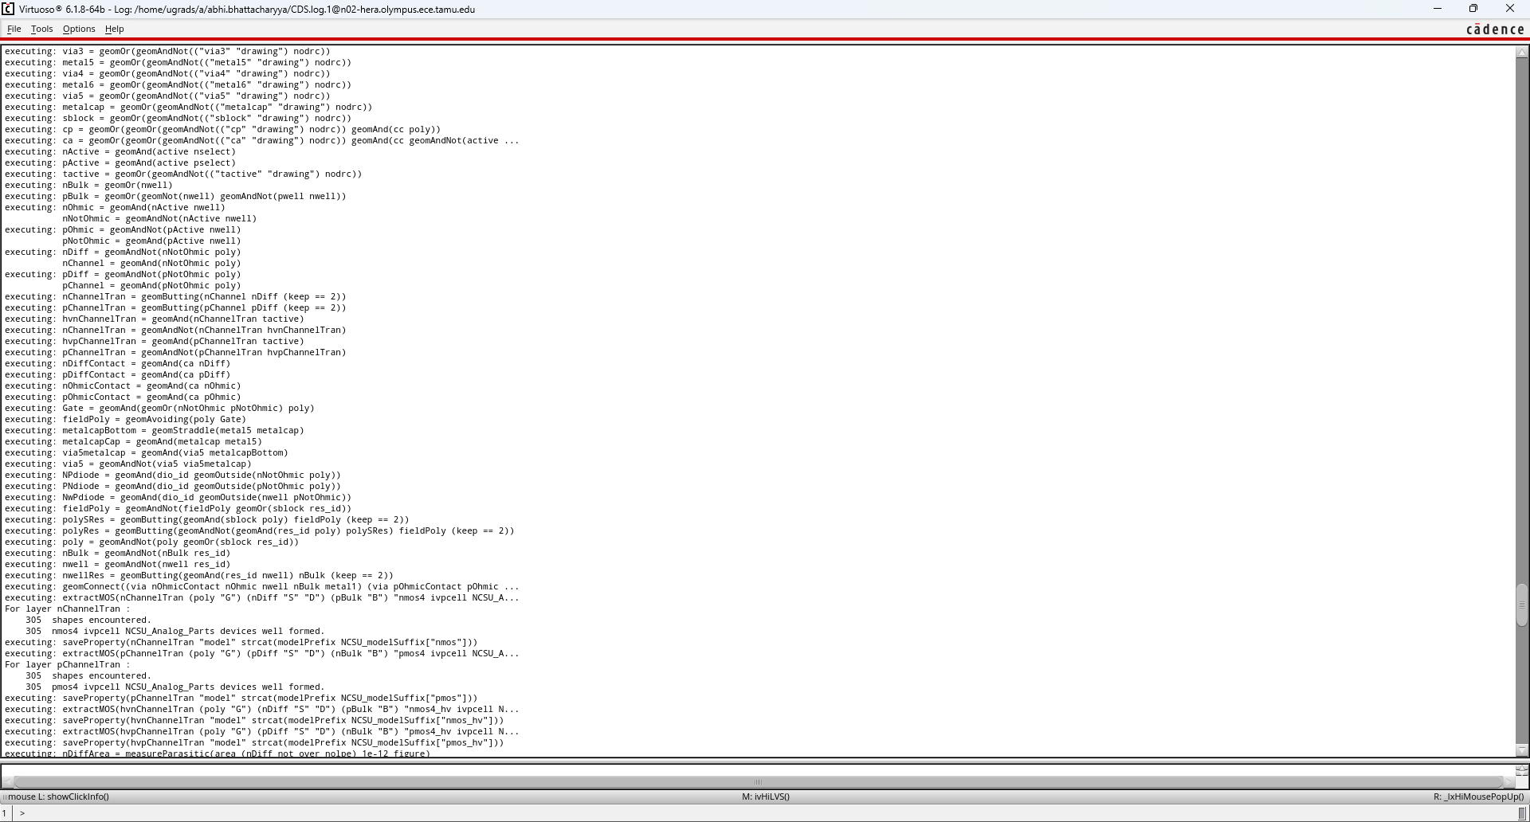
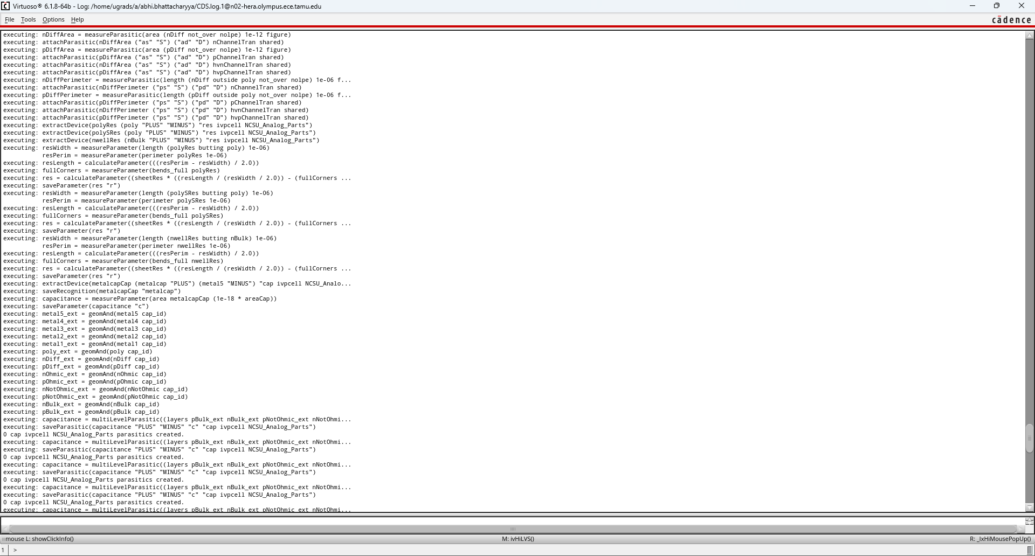
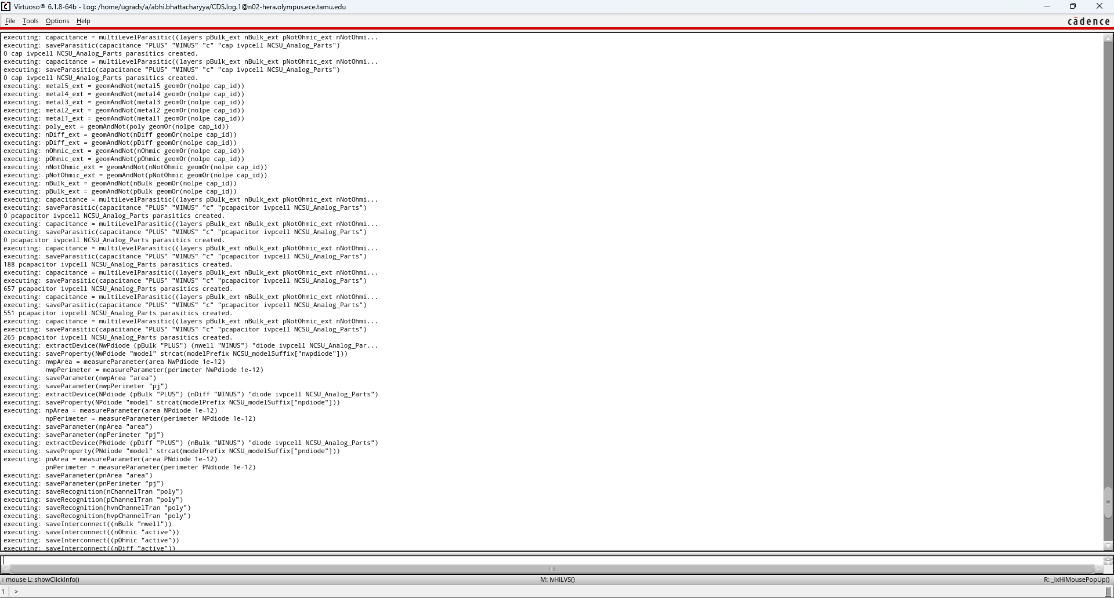
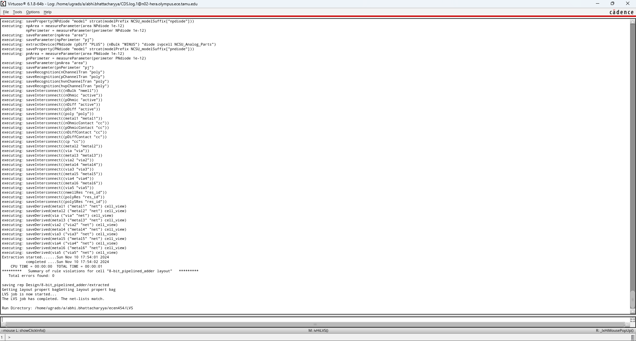

LVS:



Post-Layout Simulation
I used a pulsed voltage input to control each of the inputs A<7:0>, B<7:0>, and C such that they initialize at t = 3ns, flipping from the opposite to the specified signal. I also used a pulsed voltage to control the clock signal. For the below tests, I used a square waveform with pulse width 5ns, period 10ns, and starting at a delay of 5ns (to ensure signals A, B, and C go high before the first clock pulse and to give time to account for the flipflop’s setup time). I collected data for a total of 36ns. I did this as I flipped the inputs after 2 full clock cycles, to see the behavior of the adder transitioning at the output. As can be seen in the data, as long as the input data is given before the clock’s riding edge, the adder requires only 1 full clock cycle to calculate the output.
The results for Test 1 and Test 2 are given on the following pages. These results are also used to analyze the max clock frequency in the next part.

Test 1: 0111 1110 + 1110 0111 + 0 = 1 0110 0101

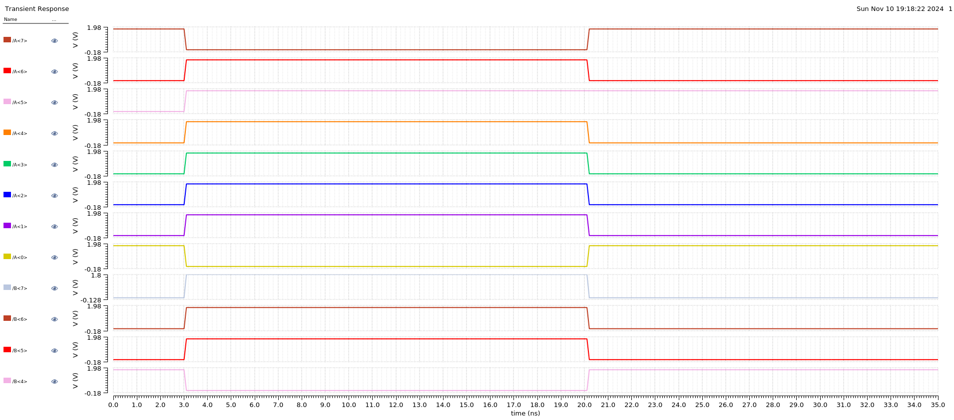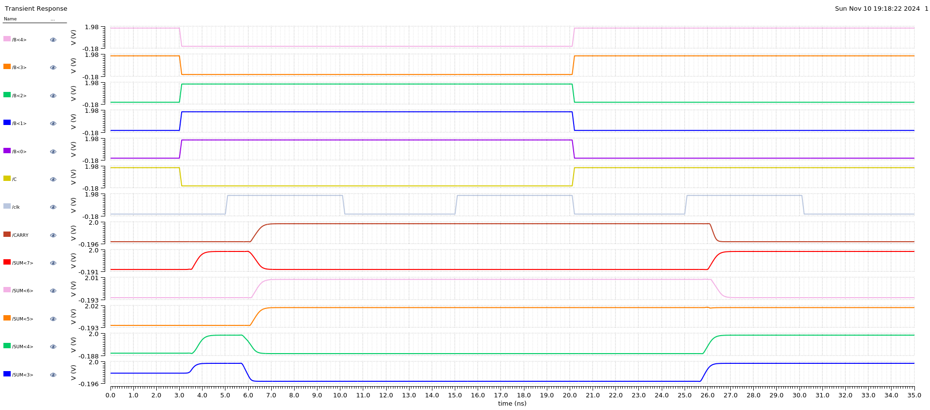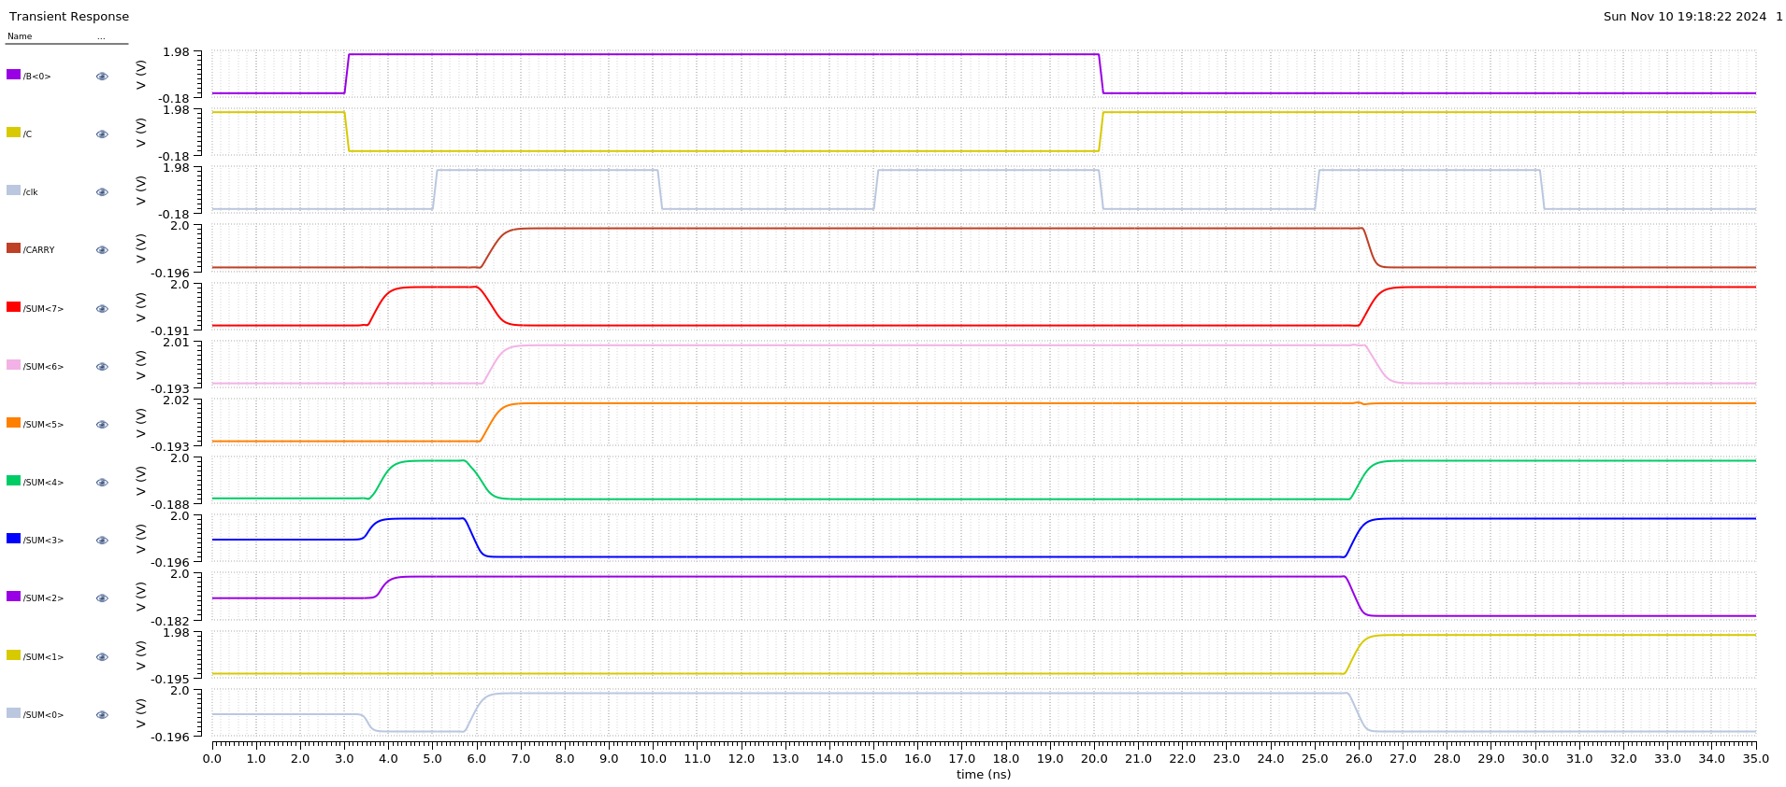
As described in the lab manual, the first test is:
A: 0111 1110
B: 1110 0111
C: 0
Expected Result: 1 0110 0101

As can be seen above, CARRY = 1 and SUM<7:0> = 0110 0101. The adder passes this test.

Test 2: 1111 1111 + 0000 0000 + 1 = 1 0000 0000
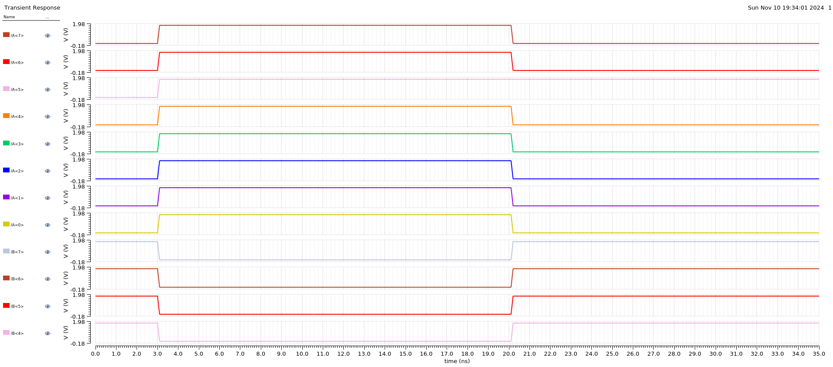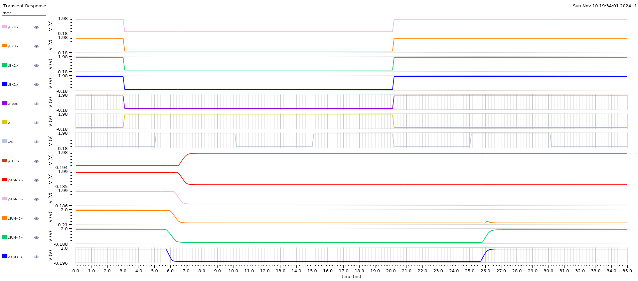
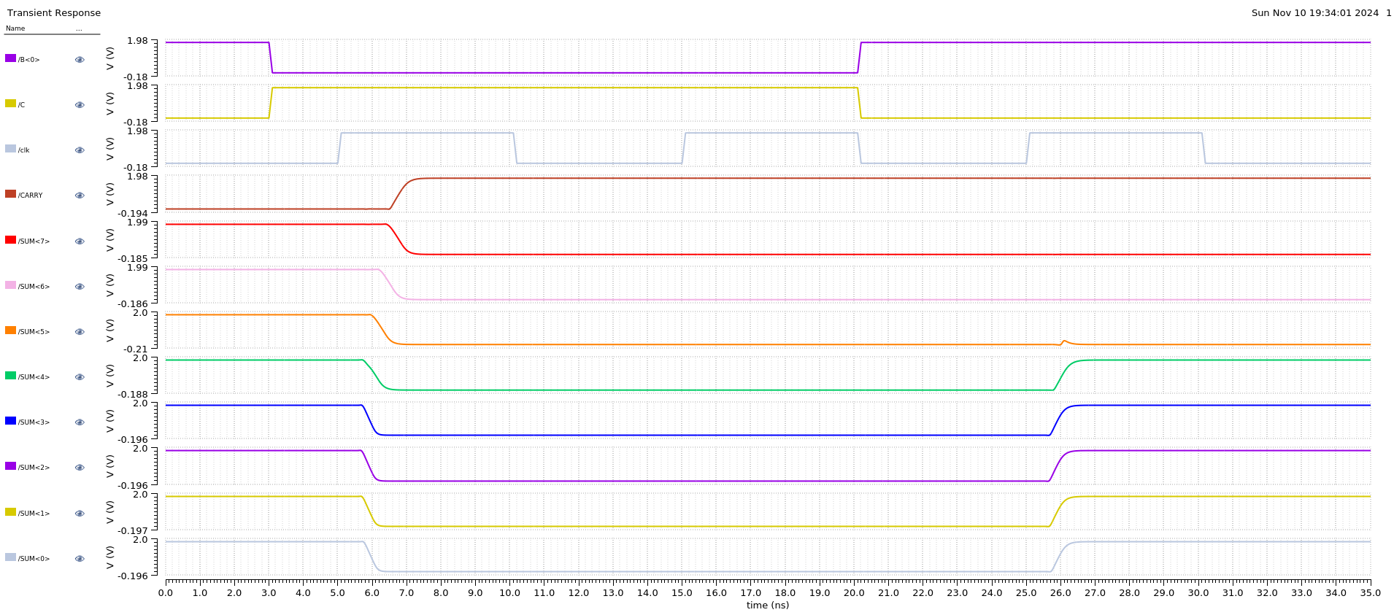
As described in the lab manual, the second test is:
A: 1111 1111
B: 0000 0000
C: 1
Expected Result: 1 0000 0000

As can be seen above, CARRY = 1 and SUM<7:0> = 0000 0000. The adder passes this test.

Best Clock Period
From Lab 6, the overall setup time for my FlipFlop design is 0.32 ns.

Test 1:

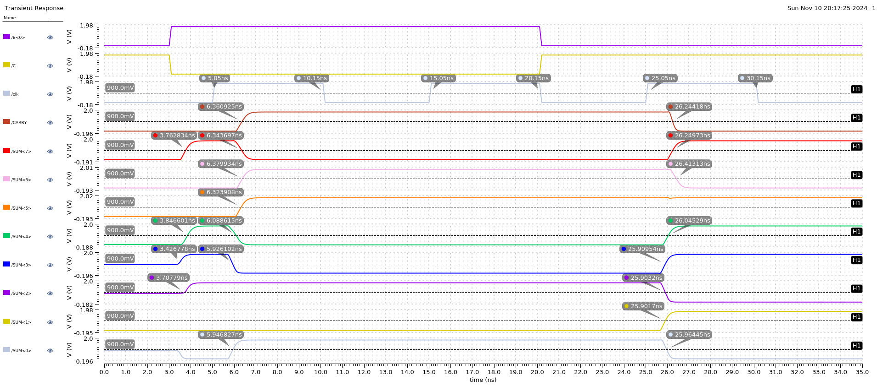
 | Signal | !Signal | Delay (Signal) | Delay (!Signal)
clk | 5.05 | 25.05 | --- | ---
CARRY | 6.361 | 26.244 | 1.311 | 1.194
SUM<7> | 6.344 | 26.2497 | 1.294 | 1.1997
SUM<6> | 6.3799 | 26.413 | 1.3299 | 1.363
SUM<5> | 6.324 | --- | 1.274 | ---
SUM<4> | 6.089 | 26.045 | 1.039 | 0.995
SUM<3> | 5.926 | 25.9095 | 0.876 | 0.8595
SUM<2> | 3.708 | 25.903 | --- | 0.853
SUM<1> | --- | 25.902 | --- | 0.852
SUM<0> | 5.947 | 25.964 | 0.897 | 0.914
 |  |  | Maximum Delay: | 1.363
T_{clk} = t_{s} + t_{d} = 0.34 + 1.363 = 1.703 ns

Test 2:
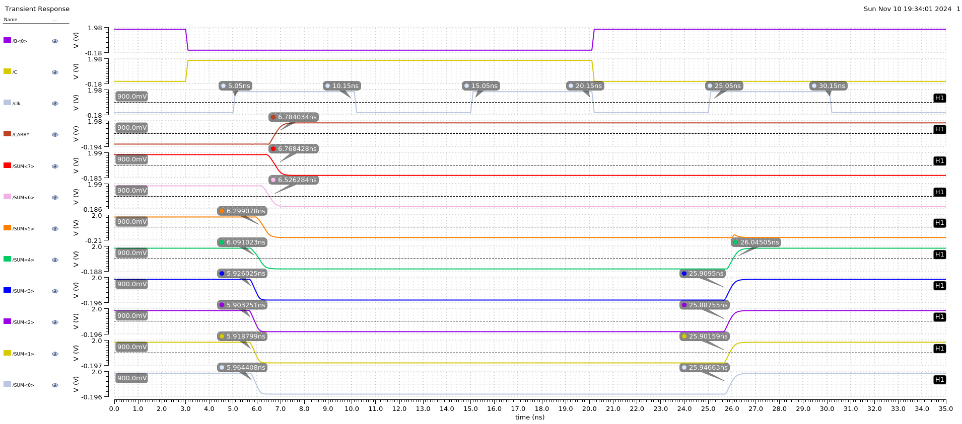
 | Signal | !Signal | Delay (Signal) | Delay (!Signal)
clk | 5.05 | 25.05 | --- | ---
CARRY | 6.784034 | --- | 1.734034 | ---
SUM<7> | 6.768 | --- | 1.718 | ---
SUM<6> | 6.526 | --- | 1.476 | ---
SUM<5> | 6.299 | --- | 1.249 | ---
SUM<4> | 6.091 | 26.045 | 1.041 | 0.995
SUM<3> | 5.926 | 25.9095 | 0.876 | 0.8595
SUM<2> | 5.903 | 25.888 | 0.853 | 0.838
SUM<1> | 5.919 | 25.902 | --- | 0.852
SUM<0> | 5.964 | 25.947 | 0.914 | 0.897
 |  |  | Maximum Delay: | 1.734034
T_{clk} = t_{s} + t_{d} = 0.34 + 1.734 = 2.074 ns

T_{clk} overall (longest) = 2.074 ns

Therefore, the best possible clock period is ~2.1ns. This is ~0.476 GHz or ~475 MHz.

Power Consumption @ ~475 MHz (t_{CLK} = 2.1ns)

Test 1: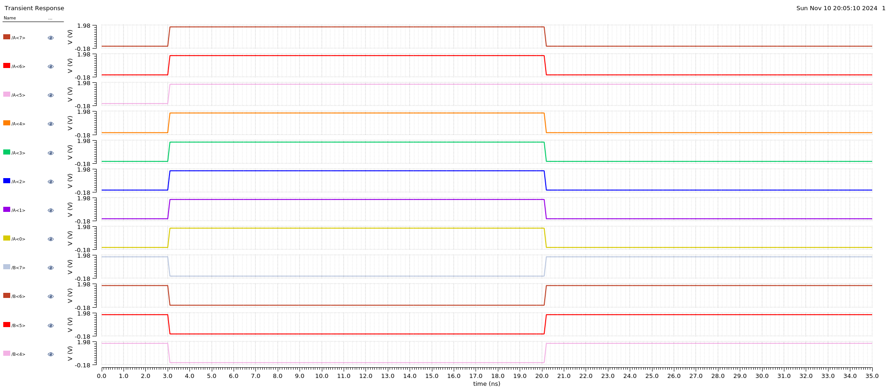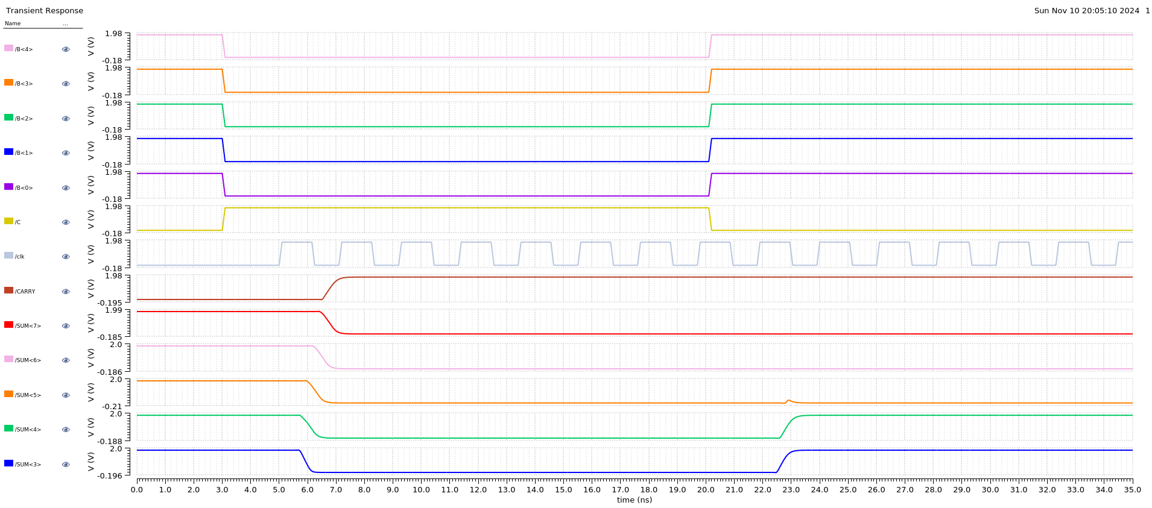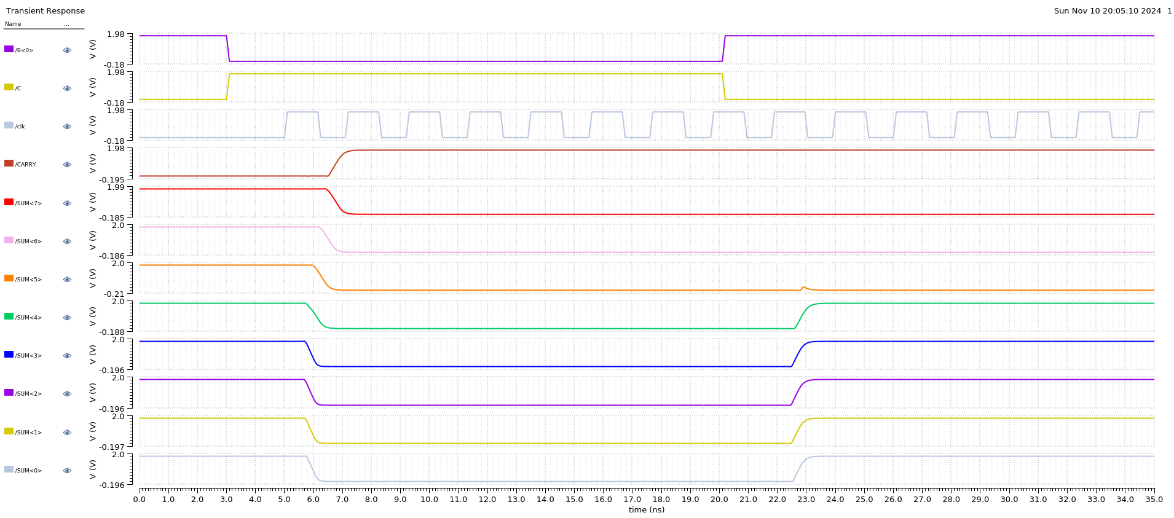

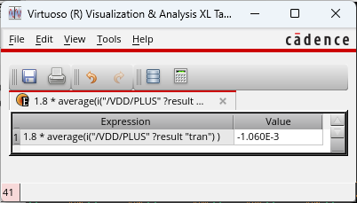

Test 2:
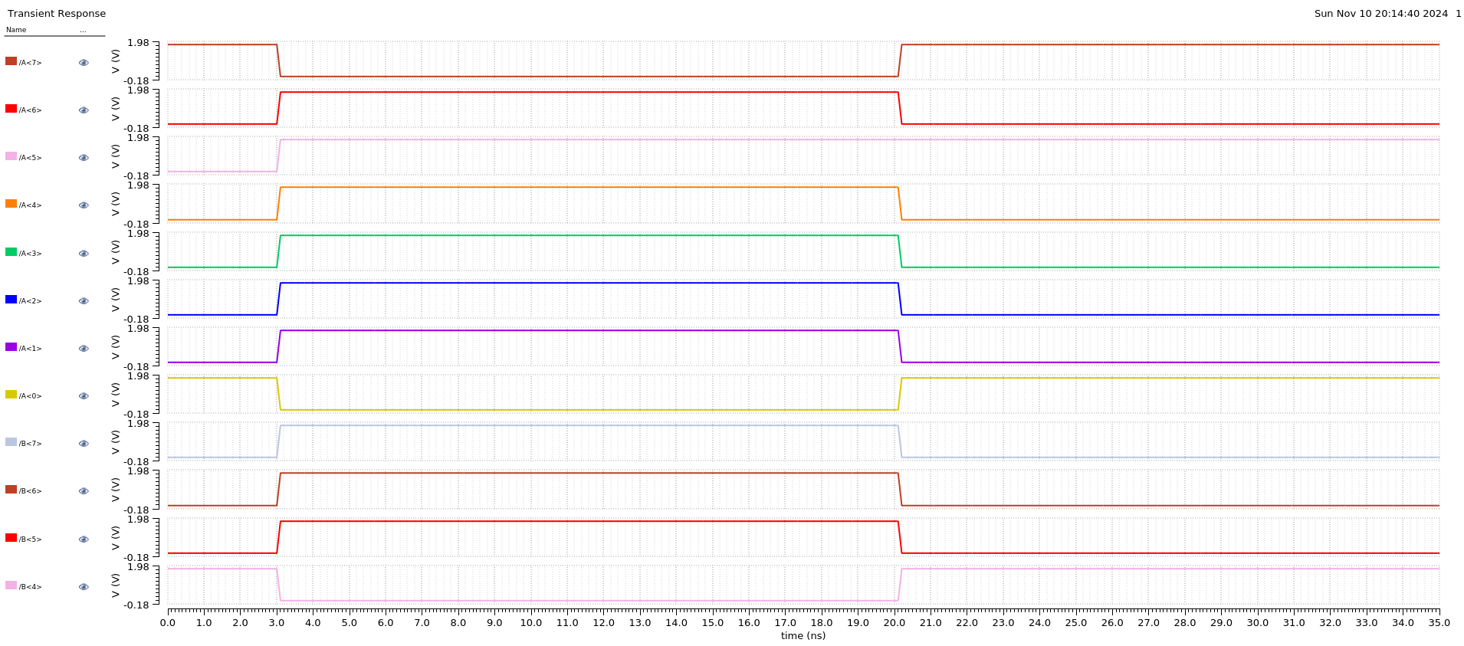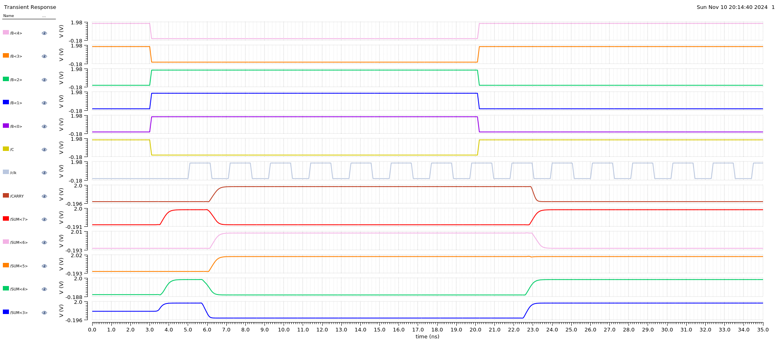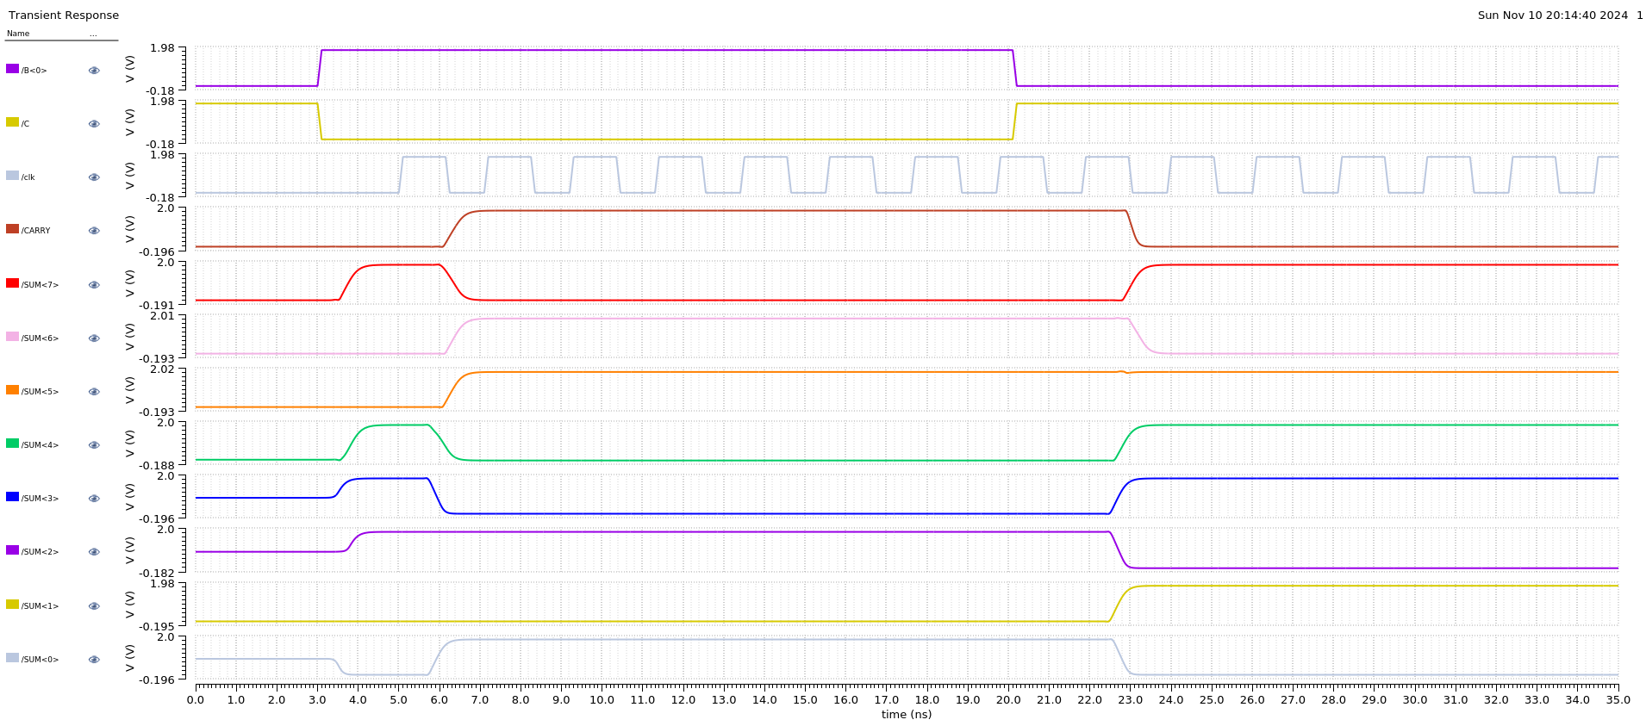

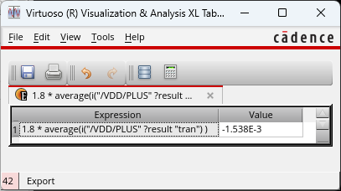

Total Area

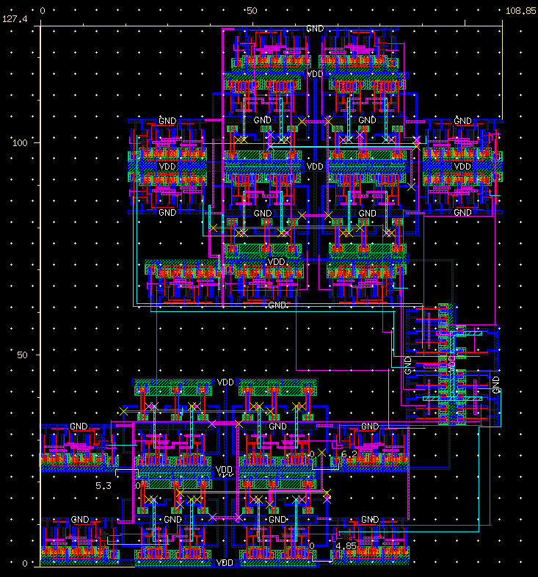
Total Area = W * H = 108.85μm * 127.4μm = 13867.49μm²

